ish¿u ysñlï weúßKs $ All Rights Reserved

St. Peter's College

St. Peter's College

St. Peter's College

புனித பேதுரு கல்லூரி

புனித பேதுரு கல்லூரி

புனித பேதுரு கல்லூரி

புனித பேதுரு கல்லூரி

புனித பேதுரு கல்லூரி

புனித பேதுரு கல்லூரி

புனித பேதுரு கல்லூரி

புனித பேதுரு கல்லூரி

Ydka; mS;r úÿy,

Ydka; mS;r úÿy,

Ydka; mS;r úÿy,

Ydka; mS;r úÿy,

Ydka; mS;r úÿy,

Ydka; mS;r úÿy,

Ydka; mS;r úÿy,

Ydka; mS;r úÿy,

Ydka; mS;r úÿy,

Ydka; mS;r úÿy,

St. Peter's College

St. Peter's College

St. Peter's College

St. Peter's College

St. Peter's College

St. Peter's College

St. Peter's College

St. Peter's College

St. Peter's College

St. Peter's College

புனித பேதுரு கல்லூரி

புனித பேதுரு கல்லூரி

புனித பேதுரு கல்லூரி

புனித பேதுரு கல்லூரி

புனித பேதுரு கல்லூரி

புனித பேதுரு கல்லூரி

புனித பேதுரு கல்லூரி

புனித பேதுரு கல்லூரி

Ydka; mS;r úÿy,

Ydka; mS;r úÿy,

Ydka; mS;r úÿy,

Ydka; mS;r úÿy,

Ydka; mS;r úÿy,

Ydka; mS;r úÿy,

Ydka; mS;r úÿy,

Ydka; mS;r úÿy,

Ydka; mS;r úÿy,

Ydka; mS;r úÿy,

St. Peter's College

St. Peter's College

St. Peter's College

St. Peter's College

St. Peter's College

St. Peter's College

St. Peter's College

34

E

**I,II**

**úoHdj**

**Science**

**meh**

**Hour**

**02**

**06 fY%aKsh – fojk jdr we.hsu - 2023**

***Grade 06 – Second Term Examination - 2023***

Ydka; mS;r úÿy, - fld<U 04

புனித பேதுரு கல்லூரி, கொழும்பு 4

***St. Peter's College - Colombo 04***



Name:……………………………………………………….. Class:………. No:……….

**Part I**

² Underline the most suitable answer.

01. Can be considered as a product of photosynthesis

i. Oxygen ii. Carbon dioxide

iii. Water vapour iv. Nitrogen

02. Underline the correct statement.

i. Animals are autotrophic

ii. Coral polyp show movements and locomotion

iii. Plants do not show locomotion

iv. Animal growth is unlimited

03. An example for brittleness is,

i. Iron ii. Aluminum iii. Copper iv. Glass

04. Which of the following can be considered as fossil fuel

i. Petroleum oil ii. Coal

iii. Petroleum gases iv. All above

05. Which of the following contains a huge body of water?

i. Rivers ii. Oceans iii. Ponds iv. Lagoons

06. Rain, snow, sleet and hail can be categorized under.

i. Surface water ii. Ground water

iii. Brackish water iv. Precipitation

07. Select the incorrect statement about the gaseous state of matter.

i. Has no definite shape

ii. Has no definite volume

iii. It does not spread throughout the container

iv. None of the above

08. Which of the following does not has a definite volume?

i. Steam ii. Sea shells iii. Stone iv. Milk

09. Which group of plants bears only the fibrous root system?

i. Paddy, arecanut, grass, palmyra ii. Arecanut, paddy, jak, palmyra

iii. Grass, mango, guava, paddy iv. Jak, guava, mango, bread fruit

10. Which of the following does not occupy space?

i. Magnet ii. Air iii. Sound iv. Sun flower

11. Can be taken as a common physical property of metals?

i. Brittleness ii. Ductility iii. Elasticity iv. All above

12. Underline the correct statement.

i. Microbial activity causes food spoilage

ii. Mosquitoes lay eggs in running water

iii. There are only harmful effects of micro-organisms

iv. None of the above

13. Which group of animals can be categorize under herbivorous?

i. Crow, squirrel, deer, cow ii. Elephant, snake, deer, cow

iii. Eagle, deer, elephant, cow iv. Cow, deer, elephant, squirrel

14. Can be used to measure the growth of a plant?

i. Metre rod ii. An auxanometer

iii. Measuring tape iv. An anemometer

15. Usage of a solar thermal stove is,

i. Grinding grains ii. Boiling water

iii. Lighting and electric bulb iv. Cutting vegetables

16. Which of the following substance can be used to make the saw dust stove other than using saw dust?

i. Rotten fruits and vegetables ii. Rice bran

iii. Hay iv. All above

17. A musical instrument that produces sound by vibrating strings is,

i. Violin ii. Trumpet iii. Tambourine iv. Horn

18. An example for a plant species with compound leaves,

i. Sesbenia ii. Jak iii. Banana iv. Mango

19. Which group of animals chew and swallow food under their feeding mechanism,

i. Cat, rat, crocodile, mosquito ii. Crow, cobra, tiger, elephant

iii. Human, dog, cat, tiger iv. Butterfly, lizard, gecko, dog

20. Factors needed for photosynthesis are,

i. Soil, water, oxygen

ii. Carbon dioxide, water, oxygen

iii. Carbon dioxide, water, Chlorophyll

iv. Oxygen, Soil, Manure

**(2 $×$ 20 $=$ 40 Marks)**

**Part II**

² **Question No. 01 is compulsory. Answer 04 more questions. Total number of questions to be answered is five.**

01. A. If you are provided with a box with a lid, a one rupee coin, a torch, a small object which can be kept inside the box.

Now cut a hole at the centre of the lid similar in size of a 50 cent coin. Cut another small hole on the other side of the box. Keep a small object in the middle of the box and close the lid.

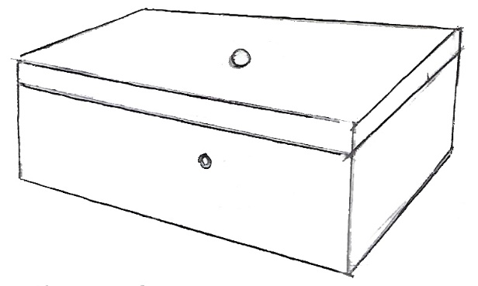

i. What would be the observation if the hole on the top is covered with a coin?

_______________________________________________________________________________________________________________________________________________________________________________________________________________

**(01)**

ii. What would be the conclusion after recording all the observations related to this experiment?

_______________________________________________________________________________________________________________________________________________________________________________________________________________

**(01)**

iii. What will be the new observation if you take away the coin and direct the light of the torch through the hole?

_______________________________________________________________________________________________________________________________________________________________________________________________________________

**(01)**

iv. Write the final conclusion of this experiment.

__________________________________________________________________________________________________________________________________________

**(01)**

B. You are provided with the following objects.

A piece of decorative glass, a metal sheet, a piece of thin glass, tissue paper, an oil paper, a thin polythene sheet, a black colour paper, a piece of wooden sheet

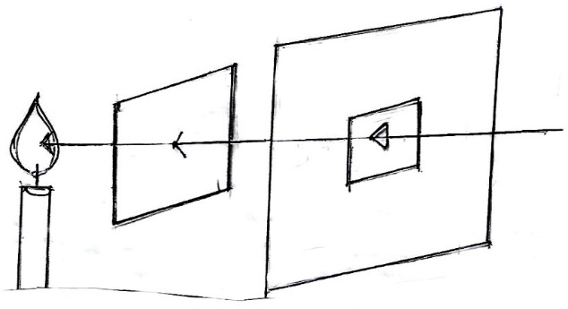

Keep each of the things that are provided to you separately in the middle and record your observations.

|  |  |  |
| --- | --- | --- |
| **A**  The objects through which both the light and the flame are clearly seen | **B**  The objects through which the light is seen but the flame is not clearly seen | **C**  The objects through which neither the light nor the flame can be seen |
| i. _____________________  ii. _____________________  iii. ____________________ | i. _____________________  ii. _____________________  iii. ____________________ | i. _____________________  ii. _____________________  iii. ____________________ |

**( $\frac{1}{2}$ $×$ $8 =4$ Marks)**

ii. Mention the 03 main types of objects that can be categorized according to the transmission of light through them.

a. - ________________________________________

b. - ________________________________________

c. - ________________________________________ **(01)**

iii. Give reasons for categorizing the moon under non luminous objects.

____________________________________________________________________________________________________________________________________________________

**(01)**

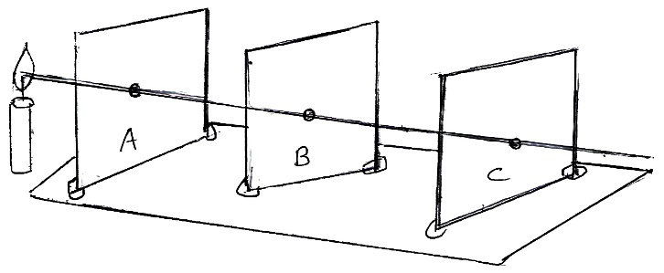

C.

i. If you change the position of ‘B’ cardboard what would be your observation?

____________________________________________________________________________________________________________________________________________________

**(01)**

ii. Write the conclusion of the above experiment.

____________________________________________________________________________________________________________________________________________________

**(02)**

iii. Which characteristic of the light is represented by the string in a straight line?

_________________________________________________________________ **(01)**

**(Total = 16 Marks)**

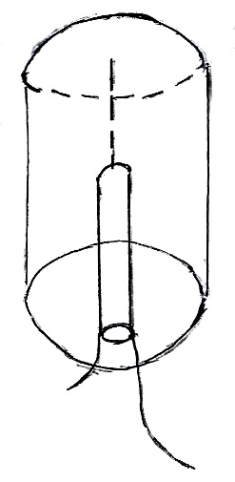

02. A.

i. Give a suitable name for the above equipment.

_________________________________________________________________ **(01)**

ii. Mention a physical property of the metal tin.

_________________________________________________________________ **(01)**

iii. Which energy is produced by shaking the iron rod?

_________________________________________________________________ **(01)**

iv. What would be the observation after bringing a bar magnet closer to the iron rod?

____________________________________________________________________________________________________________________________________________________

**(01)**

B. i. Keep the small pieces of paper on the drum and play it. What will be the observation?

_______________________________________________________ **(01)**

ii. Which object vibrated to produce sound in the above activity?

_______________________________________________________ **(01)**

C. i. Name the sensory organ for sound.

_______________________________________________________ **(01)**

ii. Explain how we get the voice.

_______________________________________________________ **(01)**

iii. How can you categorize the shouting of vendors in a market?

_______________________________________________________ **(01)**

iv. Define music.

______________________________________________________________________________________________________________________________

**(02)**

**(Total = 11 Marks)**

03. A. Given below are some observations that were recorded by a student.

When I brought the bar magnet closer to the,

|  |  |  |
| --- | --- | --- |
| **Object A** | **Object B** | **Object C** |
| Neither an attraction nor a repulsion is seen | Sometimes it attracts and sometimes it repels | Only an attraction is seen |

i. Draw the bar magnet and mark the poles.

**(02)**

ii. Which object cannot be considered as a magnetic material?

_____________________________________________________________ **(01)**

iii. What is the special feature of the object ‘B’?

_____________________________________________________________ **(01)**

iv. What is the purpose of designing an experiment for the above diagram ?

__________________________________________________________________________________________________________________________________________

**(01)**

B' i. There are many permanent magnets with different shapes.

Draw a ring magnet and a horse-shoe magnet.

Ring magnet

Horse-shoe magnet

**(02)**

ii. You are provided with bar magnets and some small nails. How can you design an experiment to investigate to identify the most powerful magnet?

____________________________________________________________________________________________________________________________________________________________________________________________________________________________________________________________________________________

**(02)**

iii. Name two groups of people who use the compass often in their day to day activities.

a. - ____________________________________________

b. - ____________________________________________ **(02)**

**(11 Marks)**

04. Nimal’s father was digging a pit with a mammoty. While he was doing his job, he uprooted some grass and weeds on the ground. Some earth worms were found inside the soil.

Fill in the blanks with the correct words.

Organisms

__________

Eg: _________

A

D

__________

Eg: Earth worm

B

__________

Eg: Bacteria

C

i. Organisms can be divided into 3 main groups. Name the following.

A - ____________________________________________

B - ____________________________________________

C - ____________________________________________

D - ____________________________________________ **(04)**

ii. What is the mode of locomotion of the earth worm?

_____________________________________________________________ **(01)**

iii. Write two common characteristics that can be seen in both the earth worm and grass.

a. - ____________________________________________

b. - ____________________________________________ **(02)**

iv. What type of fuel can be produced from rotten vegetables, hay and saw dust.

________________________________________ **(01)**

v. Which pigments are responsible for giving green colour to the leaves and write the importance of those pigment.

_____________________________________________________________________

_____________________________________________________________________

**(02)**

vi. Which property of metals is used to make the mammoty?

_____________________________________________________________ **(01)**

05. Given below is the flow chart that shows the energy conversion in a hydro power station.

**Running**

**water**

**A**

**Generators**

**Electricity**

i. Which energy source is used to generate electricity in the above picture?

_____________________________________________________________ **(01)**

ii. Name A

_____________________________________________________________ **(01)**

iii. Name 04 other sources of energy.

a. - _________________________ b. - _________________________

c. - _________________________ d. - _________________________

($\frac{1}{2}$ $×$ $4 =2$)

B. Three sisters of the same family use three rooms for studying and they use electric bulbs to read books at night time.

i. Write one method / step that can be taken to save energy of the above house.

_____________________________________________________________ **(01)**

ii. Who invented the first bulb with carbon filaments?

_____________________________________________________________ **(01)**

iii. Which energy type can be produced after lighting an electric bulb?

________________________________________________________ **(01)**

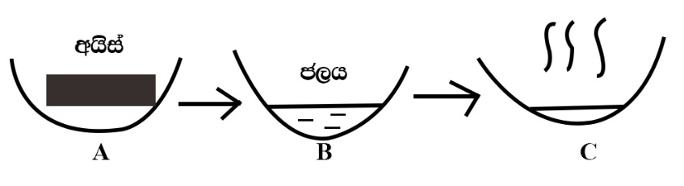

**ice**

**water**

C'

i. Name the 03 physical states of water represented by A, B and C

A - ____________________________________________

B - ____________________________________________

C - ____________________________________________ **(03)**

ii. Name another substance with all these 03 physical states.

_____________________________________________________________ **(01)**

**(11 Marks)**

06. Mark these statements ($√$) or ($×$).

i. Springs are a type of ground water. ( )

ii. It is our duty and responsibility to prevent water pollution. ( )

iii. Mili-mitres are used to measure the mass of an object. ( )

iv. Water is not needed for the rigidity of plants. ( )

v. Optical fibres are a type of flexible fibres. ( )

vi. Nuclear energy is produced by using the radio active atoms. ( )

vii. It is easy to control the flame of a saw dust stove. ( )

viii. Compound microscope can be used to measure a volume accurately. ( )

ix. Air has a mass. ( )

x. Firefly can be categorized under luminous objects. ( )

xi. The amount of salt dissolved in water is known as salinity. ( )

**(11 Marks)**